portrait of King Charles. May 15th 2024

1------- May 14th 2024

# King Charles: First official portrait since coronation is unveiled, painted by Jonathan Yeo

- <https://www.bbc.com/news/entertainment-arts-68981200>

Yeo says the butterfly by the King's shoulder symbolises "the beauty of nature and highlights the [King's] environmental causes"

**The first official painted portrait of King Charles III since his coronation has been unveiled at Buckingham Palace.**

The vast oil on canvas shows a larger-than-life King Charles in the uniform of the Welsh Guards.

The vivid red work, measuring about 8ft 6in by 6ft 6in, is by Jonathan Yeo, who has also painted Tony Blair, Sir David Attenborough and Malala Yousafzai.

Queen Camilla is said to have looked at the painting and told Yeo: "Yes, you've got him."

In the new portrait, the King is depicted, sword in hand, with a butterfly landing on his shoulder.

Unveilings are always a little nerve-wracking, both for the sitter and the artist, but particularly when one of them is a King.

Yeo jokes: "If this was seen as treasonous, I could literally pay for it with my head, which would be an appropriate way for a portrait painter to die - to have their head removed!"

In reality, Yeo isn't going to lose his head of course - no executions for a badly received portrait of a monarch, in modern times anyway.

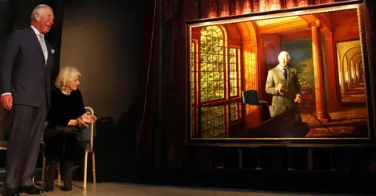Frank Augstein/AFP via Getty Images

A portrait by Ralph Heimans of the Prince of Wales, as he was then, was unveiled in London's Australia House in 2018

Fortunately, he has also already had a nod of approval from a key royal figure.

The Queen dropped in during the final sitting and said the artist had captured the King well. Yeo says the best judge of a portrait is someone who knows your sitter really well because they have instant recognition of whether it feels familiar.

The King also got a glimpse of it, says Yeo, in its "half-done state… He was initially mildly surprised by the strong colour but otherwise he seemed to be smiling approvingly".

It is a vibrant painting.

The King was made Regimental Colonel in the Welsh Guards in 1975. In the picture, the red of the uniform fades into the red background, bringing the King's face into even more prominence.

Yeo says he wanted the painting to be distinctive and a break with the past. He was aiming for something personal.

"My interest is really in figuring out who someone is and trying to get that on a canvas."

* [Why portraits still matter in an era of selfies](https://www.bbc.co.uk/news/entertainment-arts-67613307)
* [Sand portrait of King Charles created on beach](https://www.bbc.co.uk/news/uk-england-tyne-65460197)
* [Coronation coins: First ones to show King Charles wearing crown](https://www.bbc.com/newsround/65262426)
* [What does King Charles do and how has cancer changed his duties?](https://www.bbc.co.uk/news/uk-56201331)

Yeo decided to use some of the traditions of royal portraiture - the military outfit, the sword - but aimed to achieve something more modern, particularly with the deep colour and the butterfly.

He says he's referencing the tradition of official royal portraits but suggesting that's something "from the past and what's interesting about them is something a bit different from that".

"In history of art, the butterfly symbolises metamorphosis and rebirth," he explains, fitting for a portrait being painted of a monarch who has recently ascended to the throne.

The butterfly is also a reference to the King's long held interest in the environment, causes "he has championed most of his life and certainly long before they became a mainstream conversation".

Yeo says it was Charles' idea after they talked about the opportunity they had to tell a story with the portrait.

"I said, when schoolchildren are looking at this in 200 years and they're looking at the who's who of the monarchs, what clues can you give them?

"He said 'what about a butterfly landing on my shoulder?'".

Yeo began the portrait when Charles was still Prince of Wales, with the first sitting at Highgrove in June 2021.

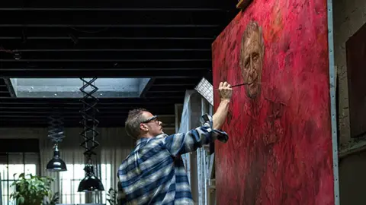Jonathan Yeo Studio

Jonathan Yeo's signature style is to place greater emphasis on capturing the sitter's character and essence

The King sat four times in all, for about an hour at a time, with the final sitting at Clarence House in November 2023. Did the artist notice any obvious change in the man after he became King?

Yeo says he's spotted "a physical change" in politicians he's painted in the past. "They physically look and feel different when they're in high office or out of it."

Yeo adds the King "had already been gaining presence and stature by the time I started it, and it went up a level again when he became King, as you'd expect".

The sittings ended before the King's cancer was diagnosed. He had a lot going on, says Yeo, with an upcoming speech at the COP Summit, but "didn't seem like someone who was physically exhausted".

He was "in good spirits", the painter adds.

King Charles posed in his full Welsh Guards uniform and had to stand leaning on his sword for around 40 minutes each time.

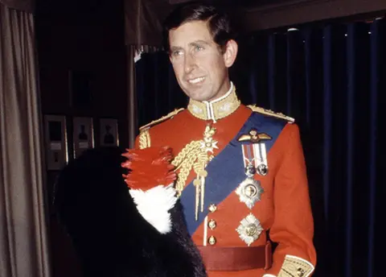Shutterstock

Prince Charles was made Regimental Colonel of the Welsh Guards in the 1970s

"He stood impressively still, and didn't get distracted like some sitters do."

Yeo won't reveal much of what they talked about during sittings, although he says Charles III has "a great sense of humour" and is a "very engaging person".

His interest in art meant Charles wanted to discuss the process of creating the work and the brushes being used. They also talked about "how he'd learned to paint and about some of the pictures on the walls".

But Yeo says "there's a sanctity to the portrait process". Your sitters "need to believe what goes on is between the two of you because that way I think they feel more comfortable about opening up".

Royal portraits in the past have had an important role to play in signifying power and projecting an image. They were part of the tools used to ensure the survival of the monarch. Some of the most memorable include Henry VIII by Hans Holbein the Younger. The Tudor king employed Holbein as court artist, although only two portraits survive.

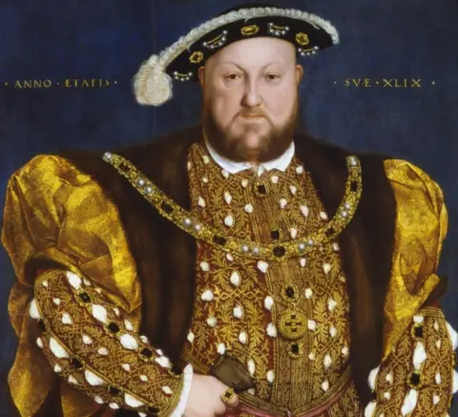Getty Images

This famous portrait of Henry VIII was painted by Hans Holbein the Younger in 1536-1537

But Yeo says our relationship with royalty has shifted since those days.

"On the one hand, we know they're real people with quirks and personality traits. We've seen that much more of them. On the other hand, we still want to buy into the mysticism and the fairy tale that they're different from us, that there's a bit of magic there."

In his portrait, he was "trying to figure out how to do both at once".

Painting a portrait of this size was "quite an operation", says Yeo. Having used his first sittings with the king for photographs and sketches, he did most of the painting between the third and fourth sittings.

He then had to hire a truck to transport the canvas and his equipment to Clarence House for the last time he saw the King.

As well as easel, painting tables and lighting, they had to "cover all the carpets in sheets so we didn't damage these priceless carpets".

Yeo also brought "a dias, a sort of platform, for me to stand on so I was up high enough to paint his face and one for him to stand on so that he's on a level as well".

The artist claims not to have been interested in getting involved in the "rigid formality" of royal portraiture previously. But as he turned 50, he began to think about how "you have to see how you measure up against the works of the past".

The portrait was commissioned by the Drapers' Company, the City of London livery company which has been collecting royal portraits for centuries.

His painting will go up in Drapers' Hall in London surrounded by "a dozen other fabulous, similarly huge portraits of Queen Victoria and various other kings and queens".

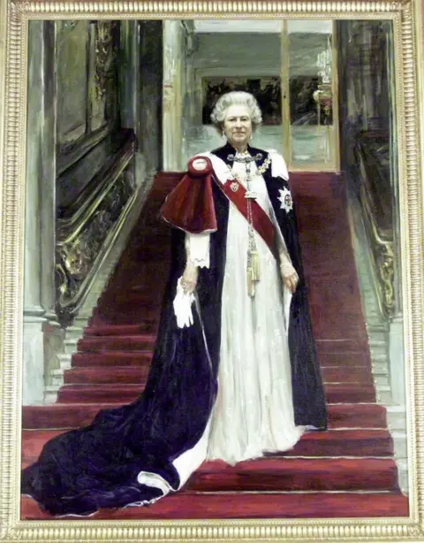Getty Images

This portrait of Queen Elizabeth II by Sergei Pavlenko was unveiled at Drapers' Hall in 2000

For him, painting Charles III was different from most previous commissions, where you start from scratch.

"All my life I'd known who he was and what he looked like so it was really just a case of deciding what to show and trying to slightly channel who he seems to be now."

He deliberately minimized the visual distractions in his portrait to "allow people to connect with the human being underneath".

There's a great deal of sympathy for the King, Yeo adds. The portrait "reflects exactly who he is, everything he represents and what he's been through".

*The portrait will go on public display at the Philip Mould Gallery in London from 16 May until 14 June. It will be displayed at Drapers' Hall from the end of August.*

# 2- King's first official painted portrait since the coronation unveiled

The King sat for Jonathan Yeo on four occasions between June 2021 and November 2023 at both Highgrove in Gloucestershire and Clarence House in London.

Tuesday 14 May 2024 19:37, UK

<https://news.sky.com/story/kings-first-official-portrait-unveiled-13135833>

The first official painted portrait of the King since the coronation has been unveiled at Buckingham Palace.

The painting was done by renowned portrait artist Jonathan Yeo, whose past subjects include Idris Elba, Cara Delevingne, Sir David Attenborough, Nicole Kidman, Malala Yousafzai, and former prime ministers Sirs David Cameron and Tony Blair.

Mr Yeo, whose work has been displayed at the Royal Academy of Arts and Smithsonian National Portrait Gallery in Washington DC, has also painted Queen Camilla and the late Prince Philip.

Unveiling his work at Buckingham Palace on Tuesday, he said: "It was a privilege and pleasure to have been commissioned by The Drapers' Company to paint this portrait of His Majesty The King, the first to be unveiled since his coronation.

"When I started this project, His Majesty the King was still His Royal Highness the Prince of Wales, and much like the butterfly I've painted hovering over his shoulder, this portrait has evolved as the subject's role in our public life has transformed.

"I do my best to capture the life experiences etched into any individual sitter's face.

"In this case, my aim was also to make reference to the traditions of Royal portraiture but in a way that reflects a 21st-century monarchy and, above all else, to communicate the subject's deep humanity.

"I'm unimaginably grateful for the opportunity to capture such an extraordinary and unique person, especially at the historic moment of becoming King."

…..

His portrait was originally commissioned in 2020 to mark his 50 years as a member of The Draper's Company in 2022.

It shows him wearing the uniform of the Welsh Guards, which he was made regimental colonel of in 1975.

The dimensions for the painting, which is oil on canvas, were specific to fit the architecture of the Drapers Hall where it will eventually hang.

t will first go on display at the Philip Mould Gallery in London from 16 May until 14 June before moving to Drapers' Hall at the end of August.

The Drapers' Company is a group of seven charitable trusts dedicated to helping disadvantaged people. Its links to the Royal Family date back to 1364 when it received its first charter from King Edward III.

# 3-- King’s portrait verdict — A knighthood for the face, off to the Tower for background

The painting by Jonathan Yeo includes an endangered monarch butterfly to symbolise how Charles’s royal role has transformed since he ascended the throne

[Kate Mansey](https://www.thetimes.co.uk/profile/kate-mansey)

Tuesday May 14 2024, 7.00pm BST, The Times

<https://www.thetimes.co.uk/article/king-charles-portrait-painting-picture-royal-news-vjz3qbddx>

The King is depicted standing before a red background wearing the uniform of the Welsh Guards, for whom he was made regimental colonel in 1975

HIS MAJESTY KING CHARLES III BY JONATHAN YEO 2024

The King said he was delighted to be a “chrysalis” as he unveiled his first official portrait as monarch, featuring a butterfly to signify his “metamorphosis” from prince to sovereign.

The artist Jonathan Yeo, who has painted Sir Tony Blair and Lord Cameron of Chipping Norton, described the King as “extraordinary and unique”, and said that he wanted the portrait to “communicate the subject’s deep humanity”.

Pulling off the heavy cover to reveal the painting, Charles, who is continuing his cancer treatment, muttered “Christ” and laughed at the effort of the task.

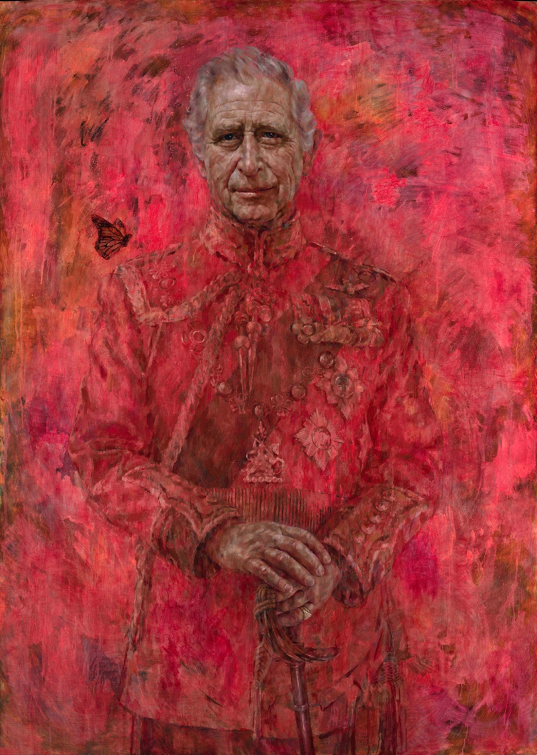

The King and Queen were present for the latest unveiling at Buckingham Palace

HIS MAJESTY KING CHARLES III BY JONATHAN YEO 2024

It depicts the King wearing the uniform of the Welsh Guards, the regiment for which he was made regimental colonel in 1975, against an ethereal background. He is know colonel-in-chief of the regiment after his accession.

Speaking at the unveiling, the artist said that he wished to explain “two artistic pieces of licence”.

Yeo said: “One is the colour, obviously, which was inspired by the colour of the bright red tunic of the Welsh Guards. And that got me thinking it would be lovely to take the colour and spray it around the picture.

“The uniform and the medals are great references to historic royal portraits of the past but it felt like this one should have a bit more dynamic and contemporary feel.

“The other thing is the butterfly. I would love to take full credit for that but it was actually the subject’s idea.”

Charles laughed and asked: “Was it?”

Yeo said: “Yes. We had a conversation at the start about how it would be nice to have a narrative element which referenced his passion for nature and the environment and you said. ‘Why not have a butterfly on my shoulder, they often do that.’ I thought, ‘Oh that’s a good idea, I wish I had thought of that.’

“Also it works as a counterpoint to the military steeliness of the sword so it’s a little visual device. And when he changed jobs halfway through the process it added resonance because you had a butterfly in art history terms as a symbol of metamorphosis.

“So with a little visual device it tells multiple stories really. Dare I say, it’s perhaps testament to the subject’s artistic instinct to add that beautiful element into the composition.”

The King joked: “Well, it was nice to know I was a chrysalis when you first met me. Well thank you and congratulations. Fantastic.”

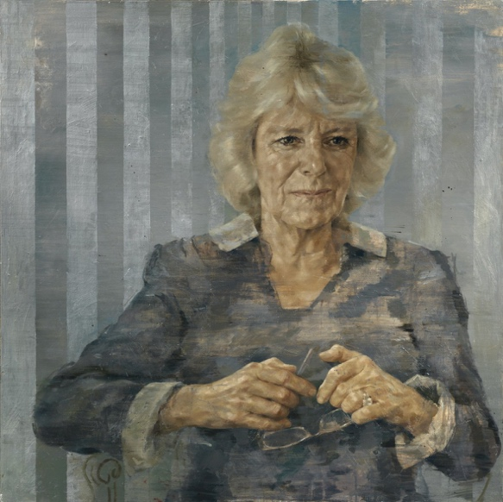

Jonathan Yeo’s portrait of HRH the Duchess of Cornwall, 2014

JONATHAN YEO

When it was pointed out that the butterfly was, in fact, an endangered monarch butterfly, Yeo said: “Yes another bit of artistic licence. It was named after William of Orange, I think, originally. Because it was orange. They are the ones most in danger.”

The King replied: “I have seen them in that extraordinary part of Mexico in a remarkable forest. Thousands of them. But it is extraordinary how butterflies do come and land on your shoulder if you are in the garden or something. I think it’s lucky if they land on you, do you know what I mean?”

Yeo had four sittings with the King, beginning in June 2021 at Highgrove when Charles was still the Prince of Wales. Yeo took drawings and photographs to work on the portrait between sittings.

The final sitting took place in November 2023, for which the artist hired a truck to transport his 7.5ft by 5.5ft canvas (8.5ft by 6.5ft once framed) to Clarence House, where he erected a platform and applied the final brushstrokes.

Yeo, 53, who had a heart attack last year which he reportedly attributes to the lingering effects of cancer in his early twenties, completed the portrait before learning that the King was ill.

He said: “I do my best to capture the life experiences etched into any individual sitter’s face. In this case, my aim was also to make reference to the traditions of [royal](https://www.thetimes.co.uk/topic/royal-family) portraiture but in a way that reflects a 21st-century monarchy and, above all else, to communicate the subject’s deep humanity.

“I’m unimaginably grateful for the opportunity to capture such an extraordinary and unique person, especially at the historic moment of becoming king.”

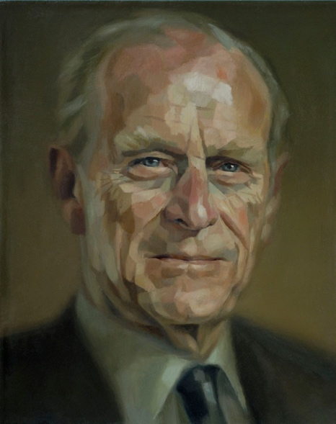

Yeo’s portrait of HRH the Duke of Edinburgh, 2008

JONATHAN YEO

Despite never attending art school, Yeo, who attended Westminster School instead, has produced portraits of royalty, prime ministers and supermodels. His father Tim was a former Tory cabinet minister whose career was derailed by scandal after it emerged he had fathered a child during an affair with a Conservative councillor, Julia Stent, jeopardising John Major’s “back to basics” campaign.

Yeo told The New York Times that his father refused to fund his dream of becoming a painter after leaving school. “He assumed I’d need to get a proper job,” he said.

However, Yeo won success for his revealing portraits and has said that older faces are easier to paint than those of younger subjects because they were more lived in.

His portraits include paintings of the [Queen](https://www.thetimes.co.uk/topic/duchess-of-cornwall), when she was still the Duchess of Cornwall, Prince Philip, Cara Delevingne, Sir David Attenborough, Nicole Kidman and Rupert Murdoch, chairman emeritus of News Corp, the publisher of The Times.

The King and Queen were present for the latest unveiling at Buckingham Palace, along with Tom Harris, the master of the Drapers’ Company, and William Charnley, past master.

The new portrait of Charles was commissioned in 2020 to celebrate his 50 years as a member of the Drapers’ Company, which fell in 2022, and can be viewed for free when it goes on display at the Philip Mould Gallery in London from May 16 to June 14. Mould has reportedly called the new royal portrait “something of a unicorn”.

From the end of August it is expected to be displayed at Drapers’ Hall.

### A monarch content to be a wallflower

Well, that was unexpected — has a portrait of a blue-blooded British monarch ever been so very pink? (Laura Freeman, chief art critic, writes)

From the moment the palace appointed Yeo, they must have known they were in for something out of the ordinary. This, after all, is the artist who collaged George W Bush’s portrait from naughty magazines and who painted plastic surgery patients as the knife sliced in. For faithful genuflection look elsewhere. No one would have guessed, though, at a picture quite so fluorescent.

• [**How Jonathan Yeo became Britain’s most-wanted portrait painter**](https://www.thetimes.co.uk/article/how-jonathan-yeo-became-britains-most-wanted-portrait-painter-rlvnwhjbj)

It’s a curiously unthrusting portrait. Traditionally, kings pushed themselves forward. Think of Hans Holbein’s Henry VIII, shoulders huge, codpiece colossal, legs bestriding his kingdom of carpet. Or Van Dyck’s Charles I on horseback shining with knightly ardour while surveying his kingdom. Much good it did him. Our Charles quite literally fades into the background, his sleeves little distinguished from the scumbled ground. (It’s a polite trick, too, for diminishing the outline of those ears.)

Pomp? Circumstance? This is a king signalling that he is content to be a wallflower, albeit of the hothouse variety. Won’t impose, mustn’t meddle.

The Times recommended Comments ( from 525)

1. It’s an outstanding portrait in my opinion.
2. Absolutely agree
3. Are we sure the endangered monarch isn’t deeper in meaning?
4. I think it’s absolutely brilliant. One of the best portraits of modern times.
5. It really is fit for a King
6. It has scale, and the colour is beautiful
7. Britain at its creative best. All the other monarchs and presidents will be jealous
8. I like it
9. God, that's lovely.
10. Very nice actually.
11. I do like the actual painting of the face but it's hard to get past all that red and pink paint
12. Looks like the XR protestors have already been at it with the tomato soup
13. I don't think you're supposed to get past it.
14. Absolutely brilliant.
15. I appear to be in the minority here, but I think it's rubbish.
16. Fair enough, beauty is in the eye of beholder. If we all liked the same things the world would be very boring indeed. Stick to your views and be proud of them.
17. I love it myself.
18. I find it a shame in that his years maybe numbered by his cancer. Would be nice to have his whole body showing his humanity rather than the somewhat gory red haze.
19. Beautiful.
20. It really is different, which is hard to pull off in a major painting
21. It’s good. Bravo

# --4 -----King Charles III's new official portrait: What the butterfly means May 15th 2024

<https://www.bbc.com/culture/article/20240503-king-charles-iii-coronation-a-year-of-royal-symbols-decoded>

**As a new official portrait of King Charles III is unveiled, a guide to the messages in recent royal iconography.**

In the year since the Coronation of King Charles III, the official images that have been unveiled – created by leading painters and photographers, etchers and engravers – reveal much about his interests. And one in particular comes through powerfully.

From the surface of countless objects encountered every day in the United Kingdom, including coins and postage stamps, intricate insignias and [official portraits](https://www.bbc.com/culture/article/20230503-what-a-kings-personal-style-reveals), a surprisingly personal message about the fragility of our world has begun to vibrate back – an urgent appeal enunciated in a vivid visual language that is remarkably fresh and new. To mark the first anniversary of the Coronation in May 2023, here is a symbol-spotter's guide to the intriguingly eco-conscious iconography of King Charles III.

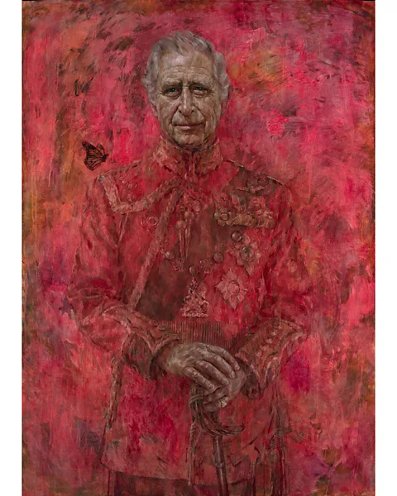Jonathan Yeo Studio

Portrait of King Charles III by Jonathan Yeo (Credit: Jonathan Yeo Studio)

## The Yeo portrait

If the first official portrait of the King to be unveiled since his Coronation [is anything to go by](https://www.bbc.co.uk/news/entertainment-arts-68981200), symbols of his devotion to ecological causes are likely to remain a leading leitmotif of royal iconography throughout his reign. The larger-than-life likeness, which measures 8ft 6in by 6ft 6in, is the work of British artist Jonathan Yeo, who has previously painted the King's father, Prince Philip, the late Duke of Edinburgh, and Charles's wife, Queen Camilla. Here, the uniformed figure of Charles appears to be emerging from a heavy haze – a vivid vermillion mist that tinges everything save the King's incongruously serene face, his sympathetic hands (which rest on his sword's pommel), and a small monarch butterfly about to land on his sovereign shoulder.

In any other era, perhaps, the rejuvenating insect's invocation in such a context might be interpreted straightforwardly as an emblem of royal rebirth – a new monarch beginning to spread his wings. But here, the fug of crimson is too apocalyptic for such easy cheeriness. Some subspecies of the monarch butterfly are, after all, [vulnerable to endangerment](https://www.bbc.com/future/article/20240208-the-case-of-the-missing-monarchs-the-one-thing-humans-can-do-to-save-the-butterflies). Does the butterfly, once a predictable memento mori prop in Old Master still lifes, represent a wider warning – an exhilarating exhortation to pause and appreciate the fine, fragile, [fleetingness of life](https://www.bbc.com/culture/article/20210915-butterflies-the-ultimate-icon-of-our-fragility)?

The Barford Portrait

…..

The Coronation invitation

…….

The Coronation photo

…….

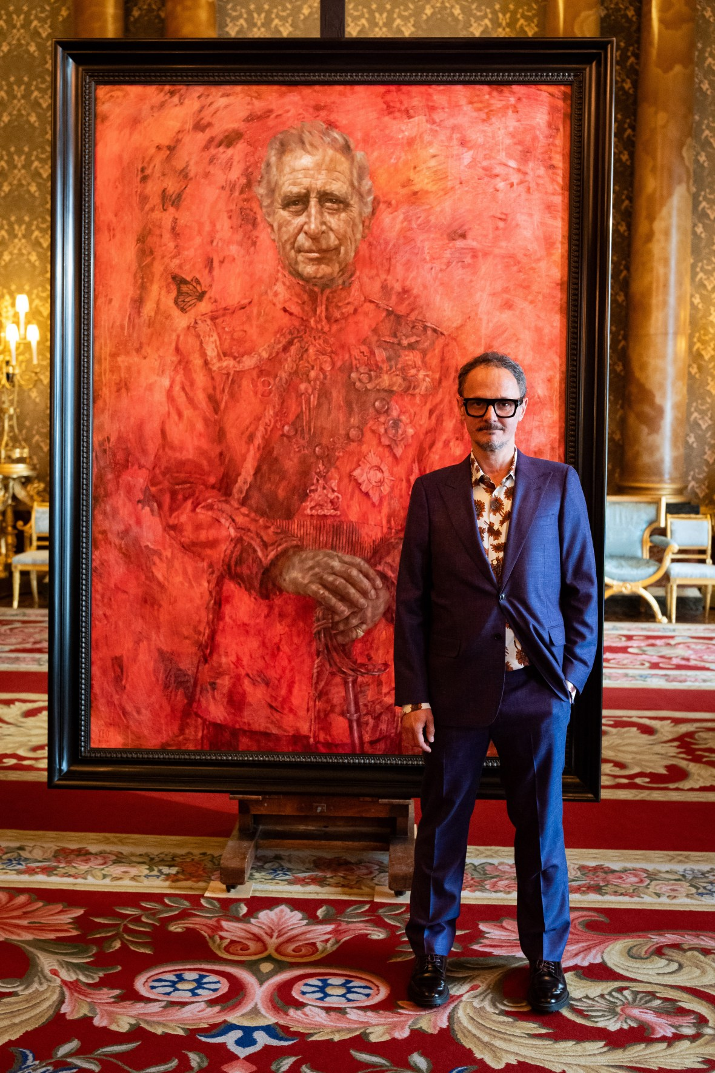

Jonathan Yeo at the unveiling of his portrait of the King, in the blue drawing room at Buckingham Palace

AARON CHOWN/PA

Whatever you make of the background — too disobedient for my loyalist tastes — the face is beautifully done. When sitting for a portrait, there’s generally an agreement that you won’t do anything too drastic with your appearance. No radical haircut, no extreme weight gain or loss. But you cannot plan for the gains and losses of life, and it is these that leave lasting traces.

When Yeo started this portrait in June 2021, his subject was still the Prince of Wales. The sittings continued after the death of Queen Elizabeth and the coronation last May. Sadness, self-possession and resolve each take their turn across a face that is subtly shifting. The hands are nervous and worn.

As for the butterfly, it feels almost Tudor. A symbol to be puzzled over and decoded. A nod to the King’s environmentalism? The transformation of a princely caterpillar into a kingly butterfly? A metaphor for the light touch of monarchy in the 21st century?

So, to honours. I award Yeo a knighthood for the face, an MBE for the hands, and off to the Tower with the background to await a grisly execution.

-----5 ---- **King Charles: 'That is quite red indeed’ - reaction to new portrait**

<https://www.bbc.com/news/uk-69013423>

The BBC asked members of the public what they thought of the newly unveiled official portrait of King Charles.

Many were initially taken aback by the vivid red colour with some saying it looked like fire. Others described the painting as “unexpected” but “modern”.

The oil painting by Jonathan Yeo is the first portrait of the King since his coronation.

**--- 6- King Charles’s first official portrait since his coronation unveiled** -May 14, 2024

## Artist Jonathan Yeo says Charles 'makes you laugh and asks lots of questions' in sittings - and suggested an addition: a butterfly

<https://inews.co.uk/news/kings-first-official-portrait-since-his-coronation-unveiled-3056128?ico=in-line_link>

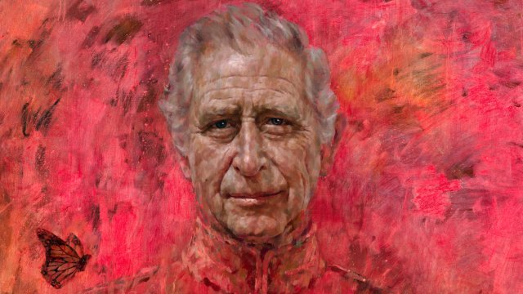Charles wears the uniform of the Welsh Guards (Photo: Handout/His Majesty King Charles III by Jonathan Yeo via Getty)

[author avatar image](https://inews.co.uk/author/brendan-mcfadden)

By [Brendan McFadden](https://inews.co.uk/author/brendan-mcfadden) May 14, 2024 8:09 pm(Updated 9:37 pm)

[The King](https://inews.co.uk/topic/king-charles-iii?ico=in-line_link) has unveiled the first completed official portrait of himself since the coronation.

The painting, by British artist Jonathan Yeo, depicts Charles wearing the uniform of the Welsh Guards, of which he was made Regimental Colonel in 1975. It also includes a butterfly – as suggested by the monarch.

The painting, commissioned to celebrate his 50 years as a member of The Drapers’ Company in 2022, was unveiled at Buckingham Palace on Tuesday.

The uniform of the Welsh Guards inspired the colour red, which was painted over much of the portrait, with Yeo saying he felt the artwork should have more of a “dynamic and contemporary feel”.

The butterfly is hovering over the King’s shoulder, and was added in by Yeo at Charles’s suggestion. After the unveiling, Yeo said he would “love to take full credit for that” but it was “actually the subject’s idea”.

During a conversation with the King, Yeo said they discussed how it would be “nice to have a narrative element which referenced his passion for nature and environment”. Highlighting how Charles “changed jobs halfway through the process, he pointed out the butterfly is a “symbol of metamorphosis” so it “tells multiple stories”.

After Yeo’s speech, the King joked: “It’s nice to know I was a chrysalis when you first met me,” which was met with laughter.

The Queen said she “hopes it is going to be seen by lots of people”.

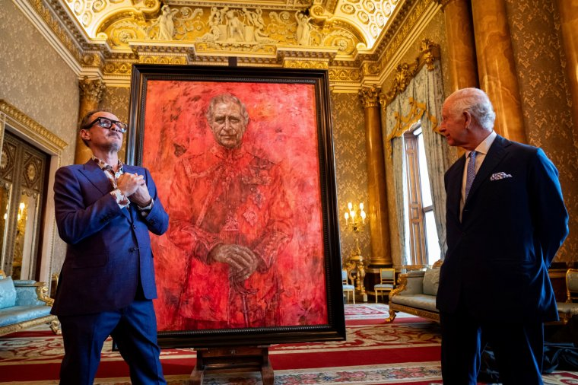Artist Jonathan Yeo and King Charles III at the unveiling of Yeo’s portrait (Photo: Aaron Chown/PA)

The portrait will go on public display for a month at the Philip Mould Gallery in London, from May 16 until June 14. Entry is free. It is expected to be displayed at Drapers’ Hall from the end of August.

Yeo has previously produced commissions of Prince Philip, Queen Camilla, Sir Tony Blair and Lord Cameron.

After the unveiling, Yeo said the secret to a good portrait is “having an interesting subject to start with, and you couldn’t ask for a better one than this” – before quickly adding “other than Your Majesty” referring to Camilla who he has previously painted.

The artist said The Drapers’ Company had asked for the portrait to be a specific scale, and there was a preference for Charles being in uniform, but no other directions from them or the King, which Yeo added was “exciting and also a little bit daunting”.

Charles “couldn’t be more lively” and was “very easy company” during their sittings, he added. “He kind of makes you laugh and asks lots of questions, and he’s interested in art as well so there’s always lots to talk about.”

Asked if the King’s accession to the throne had altered his approach, Yeo said: “Maybe very slightly … I’d sort of started it but not got very far when he changed jobs, and you can sense his, you know, his face doesn’t change particularly, but I have seen it in politicians, in other sittings before, when people are in office, they do sort of move differently.

“And so I think I was conscious of that. And then when I saw him again, you had this sense of, I don’t know how to explain it, but he seemed very comfortable with himself. And so it’s a sort of subtle thing, but yes, it’s definitely there.”

## Read Next

[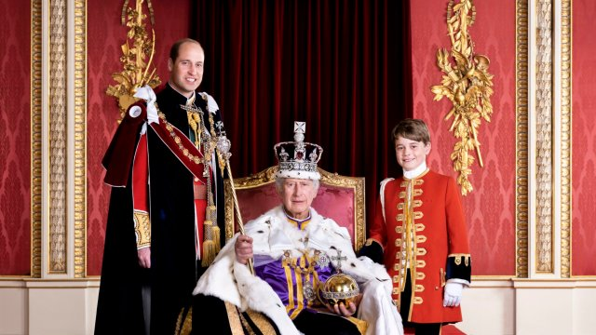](https://inews.co.uk/news/king-marks-coronation-with-new-portrait-showing-him-and-his-two-heirs-2338806?ico=related_article_inline)

[News](https://inews.co.uk/category/news?ico=related_article_inline)

## [King marks coronation with new portrait showing him and the two heirs to his throne](https://inews.co.uk/news/king-marks-coronation-with-new-portrait-showing-him-and-his-two-heirs-2338806?ico=related_article_inline" \o "King marks coronation with new portrait showing him and the two heirs to his throne)

[Read More](https://inews.co.uk/news/king-marks-coronation-with-new-portrait-showing-him-and-his-two-heirs-2338806?ico=related_article_inline)

Yeo said it was “always the person who knows the subject best who gives you the instant visual feedback” and when he could tell Camilla “liked it, or at least recognised it, I knew I was kind of nearly there with it”.

The canvas size – approximately eight-and-a-half by six-and-a-half feet when framed – was carefully considered to fit within the architecture of Drapers’ Hall in the City of London, and the context of the works it will eventually hang alongside.

Yeo had four sittings with the King, beginning when Charles was Prince of Wales in June 2021 at Highgrove, and later at Clarence House. The last sitting took place in November last year at Clarence House.

The artist also worked from drawings and photographs, allowing him to continue in his London studio between sittings.

Yeo said: “It was a privilege and pleasure to have been commissioned by The Drapers’ Company to paint this portrait of His Majesty The King, the first to be unveiled since his coronation.

“When I started this project, His Majesty The King was still His Royal Highness The Prince of Wales, and much like the butterfly I’ve painted hovering over his shoulder, this portrait has evolved as the subject’s role in our public life has transformed.

“I do my best to capture the life experiences etched into any individual sitter’s face. In this case, my aim was also to make reference to the traditions of royal portraiture but in a way that reflects a 21st-century monarchy and, above all else, to communicate the subject’s deep humanity.

“I’m unimaginably grateful for the opportunity to capture such an extraordinary and unique person, especially at the historic moment of becoming King.”

At Buckingham Palace on Tuesday, the King and Queen were met by The Master of The Drapers’ Company, Tom Harris, and Past Master William Charnley.

Guests included other members of The Drapers’ Company, students and staff from the Drapers’ Academy, Welsh Guards and Yeo’s family.

The Drapers’ Company dates back more than 600 years, to when a group of merchants came together to promote their trade in woollen cloth in London. As their guild and fellowship grew, they made philanthropy part of their plan.

The company has now evolved from a trade association into a grant-giving body.

Philip Mould said Yeo’s painting was the “most progressive formal royal portrait” created for a “very long time”.

He added: “As it’s such an important image, it’s quite exciting that the public has the opportunity to get close.”

He said monarchy was about “continuity, a touch of divinity” while modern art was “edgy” and it was “difficult to pull off both”, but Yeo had done it.