Michael Gove under investigation about financial interests – but nobody knows what
By: Jessica Frank-Keyes 29 February 2024
https://www.cityam.com/michael-gove-under-investigation-about-financial-interests-but-nobody-knows-what/
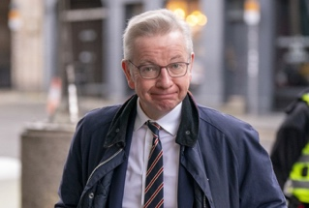
Michael Gove is under investigation by Parliament’s standards watchdog, it has emerged.
The standards commissioner Daniel Greenberg opened the probe into the secretary of state for housing, communities and local government on Wednesday.
It relates to the cabinet minister’s register of financial interests, the Standards Commissioner’s website states – but it is not known what the investigation relates to.
Details of investigations remain under wraps until inquiries conclude, while those MPs being investigated are not allowed to discuss the allegations.
However, the news comes after the Guardian reported last week that Gove failed to register VIP hospitality he received at a football match with a Conservative Party donor. Per the code of conduct MPs must register all gifts, hospitality and benefits worth over £300.
The donor’s firm was given a referral by Gove to officials for personal protective equipment (PPE) contracts during the Covid-19 pandemic reportedly worth multi-millions.
In 2021, Gove attended a Queens Park Rangers match with David Meller, whose firm Meller Designs scored six PPE contracts worth £164m after Gove’s referral, the Guardian reported.
But Gove’s spokesperson told the Guardian the failure to declare the two complimentary tickets was an “oversight” and he had written to parliament to inform them of the omission.
Gove is among seven MPs being investigated over standards – including deputy speaker Dame Eleanor Laing, Red Wall Tory Miriam Cates and independent MP Andrew Bridgen.
Gove’s spokesperson said: “Mr Gove is grateful to the Guardian for bringing this matter to his attention.
“He has written to the relevant parliamentary authorities to inform them of a potential omission from the register of members’ financial interests regarding two complimentary tickets he received from Queens Park Rangers Football Club to a match in August 2021.
“Mr Gove routinely declares his attendance at such events in his role as an MP and government minister, as evidenced by other entries in his register of interests and ministerial transparency returns. He apologises for any oversight on his part.”
Former St James’s Place boss denied £450k bonus after tumultuous 2023

