King’s English – Oct 31st 2023

1 – The Daily Telegraph

King’s English and Cockney replaced by three new accents, study finds
Britons depart from overtly class-based post-war speech epitomised by either clipped vowels or working-class dialects
By Charles Hymas, Home Affairs Editor 30 October 2023

Adele speaks estuary English; Stormzy speaks multicultural London English; while Prince Harry speaks standard southern British English
The King’s English and Cockney have all but disappeared among young people as three new accents have emerged, research has found.
Voice analysis found the two accents had been overtaken by standard southern British English (SSBE), as articulated by Ellie Goulding; estuary English, as spoken by Adele; and multicultural London English, as voiced by Stormzy.
The research, using computer algorithms to analyse voices of adults aged 18 to 33, shows how far Britons have departed from the overtly class-based post-war accents epitomised by the clipped vowels in the King’s English of BBC presenters and the working-class cockney of film stars such as Michael Caine and Barbara Windsor.
The voices of nearly 200 people from across south-east England and London were recorded, then analysed by a specially designed algorithm that listened to how they spoke and grouped them by how similarly they pronounced vowels in different words.
Around 26 per cent of those surveyed by the researchers at Essex University spoke estuary English, which has similarities with Cockney, but is more muted and closer to received pronunciation, euphemistically known as the King’s or Queen’s English.
Estuary English speakers pronounce words such as “house” more like “hahs”, but not as extreme as found in Cockney.
The accent, so named because it has extended out along the Thames estuary, is spoken across the South East, but particularly in parts of Essex, and is similar to how Stacey Dooley, Olly Murs, Adele or Jay Blades speak.
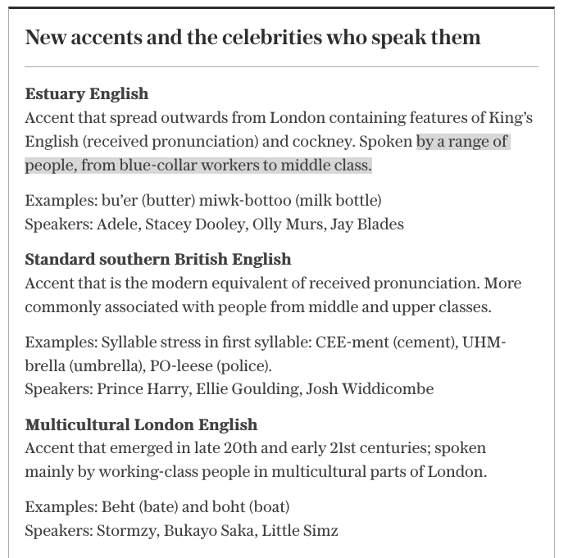

SSBE, which is typically perceived as a prestigious, “standard”- or “neutral”-sounding accent, is a modern, updated version of received pronunciation.
SSBE speakers comprised 49 per cent of the sample analysed by the researchers, led by Dr Amanda Cole, a lecturer in language and linguistics at Essex University.
Such speakers tend to say words like “goose” with the tongue further forward in the mouth – sounding a bit more like “geese” – than what would be expected in received pronunciation, according to Dr Cole.
This drift away from received pronunciation was evident in the changing accent of Queen Elizabeth II over her lifetime, spanning the changing diction of the nation from post-war Britain to the birth of the 21st century.
A feature of SSBE and estuary English is the glottal stop. In estuary English, it replaces the ‘t’ in wa’er (water), be’er (better) and ci’y (city). But in SSBE, it only replaces the ‘t’ at the end of the word, such as wha’ (what), or bu’ (but).
Speakers include Ellie Goulding, Josh Widdicombe and potentially even Prince Harry.

Around 25 per cent of the young people used the third accent, multicultural London English.
They pronounced the vowels in words like bate and boat with the tongue starting at a point higher up in the mouth compared to standard southern British English, so that they might sound a little bit more like “beht” and “boht”.
They tended to be Asian British or black British and many were from London, but there were also people from across the South East who spoke with elements of a multicultural London English accent.
England footballer Bukayo Saka, and rappers Little Simz and Stormzy are examples of people with these features in their speech.
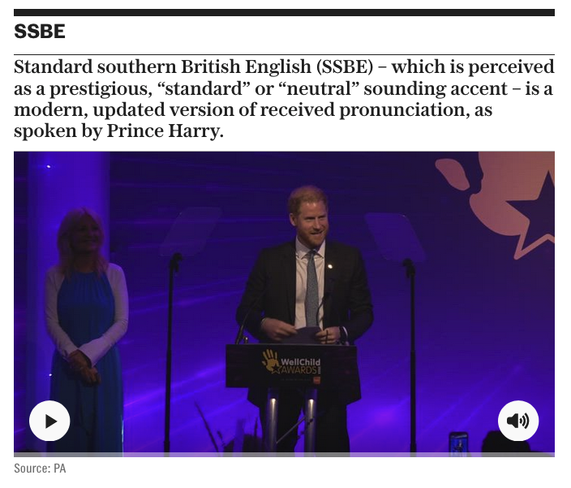
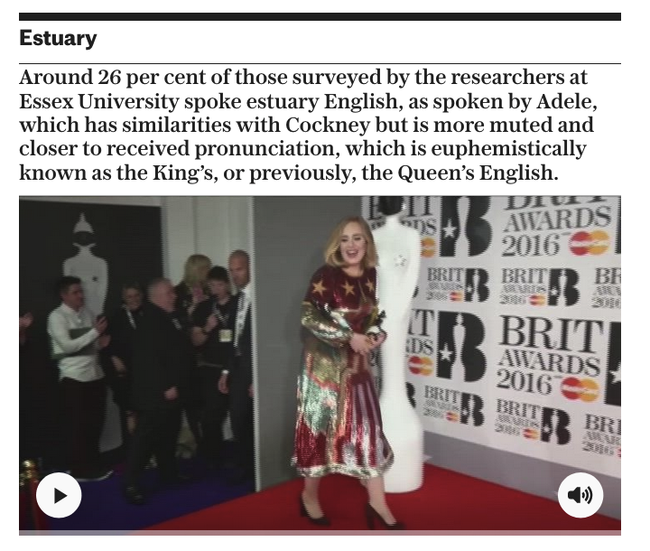

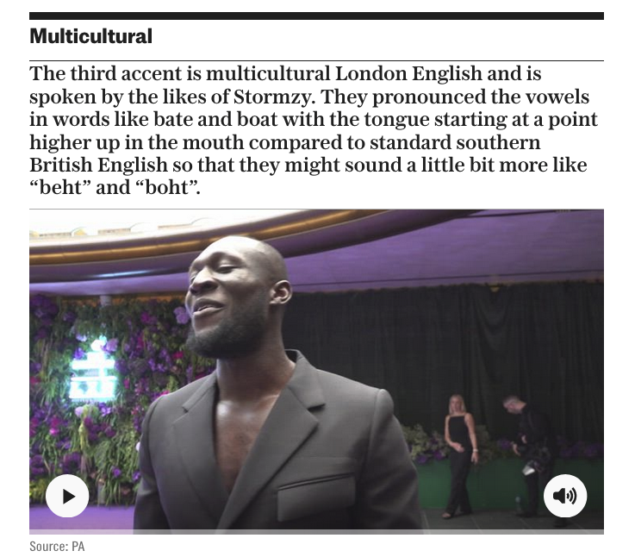
However, gone from among those surveyed was any measurable evidence of the King’s English or Cockney. “Cockney, the working-class London accent of Barbara Windsor or Michael Caine, and received pronunciation, which some call Queen’s English (or perhaps now King’s English), did not appear in our analysis,” said Dr Cole.
“That’s not to say that there aren’t any young people in our sample who might have spoken these accents but, if so, they were too few and far between for the algorithm to identify.”
Dr Cole said the shift in accents was a result of increased movement of people, resulting in greater contact between dialects, the growth of universal education and literacy and people buying into the idea that there is a “correct” or “standard” way of speaking.
“Standard southern British English and estuary English are not as different from each other as Cockney and received pronunciation. This could be evidence of what’s known as dialect levelling – where young people from different parts of the region now speak more similarly to each other than their parents or grandparents did,” she said.
Speakers of standard southern British English and estuary English generally tended to be white British, and women were more likely than men to speak the former, which is closer to the King’s English.

‘Women chastised for accents’
“It’s not surprising to find that women speak in a more socially prestigious way, as much previous research suggests women are often more chastised for speaking with regional accents than men,” said Dr Cole.
Estuary English emerged as a phenomenon in the 1980s and 1990s, with politicians such as Gillian Shephard, then education secretary, bemoaning its spread as evidence of a decline in speaking standards from the King’s English.
“Attempting to prevent accents from changing is like sweeping back an incoming tide with a broom – fruitless and defying nature. Instead, we should embrace linguistic diversity, work to combat accentism (discrimination based on a person’s accent), and accept that accents will always continue to change,” said Dr Cole.

COMMENTS (most liked) – October 31st 7.28am
Multicultural London English is an abomination.
Yo Fam! 🤣 it’s embarrassing isn’t it.
Innit
The faux Jamaican gangster patois is utterly dreadful. An' ting.
I beg your pardon?
Talk properly. Fool.
I was watching the new All Creatures Great & Small, was surprised to see farmers of colour in that location in the 1940’s ….
Were they farmers?
Cannabis?
Multicultural London English is an abomination. I can't listen to it.
Totally agree….I always switch off the radio or television when I hear it.
The BBC particularly loves its multicultural London accents, innit
The headline should be: 'London accents become even more unpleasant for everyone else!'
Nailed it.
So true!
I love it when middle class white kids try to sound like Stormzy. Morons.... edited
Who?
Agreed
So basically southern, immigrant and common.
…and ignorant.
Broad cockney was destined to become an extinct accent the moment that the white population who had lived in the eastern central parts of London for the last 200 or 300 years began moving out with house clearances and people from foreign lands and alien cultures moved in.
What with the the gentrification of so much of working class Boroughs and the first steady and then rapid expansion of black and muslim communities, the London I knew 50 years ago has just about vanished.
And it really hasn't improved one bit.
Andy Capp lived in Hartlepool, Co Durham. Tougher than any cockney. Y’d never ‘ave understood ‘im. Luckily Reg Smythe translated for us.
I tried to spell cockney in a cockney accent, but the auto-mod would not let me split the word because it decided the c**k bit was naughty. Not sure how it would interpret me writing about male chickens…
'Multicultural English' is a polite term for a kind of pidgin English with a Jamaican/Caribbean accent. I have never heard it spoken by anyone I thought was intelligent and its increasing popularity amongst young white Britons, copying their cool black friends, is depressing. The main reason why is its obvious childishness. You know how young children have trouble pronouncing the 'th' sound so they use a 'd' sound instead? When I hear a twenty-five year old saying 'dem tings' instead of 'them things' (or preferably 'those things') they just remind me of young children, with all the intellectual sophistication of a young child.

Correct. Intelligence is definitely measurable by proficiency in language.
Evolution is not the same as dumbing down.
Research focused on three accents in the south. Wow. Missed most of England.
I'm sure you meant to append '...and indeed other parts of the UK.'
Yurr, werr bist talking aboot?
Sewer English, Criminal English and Thicko English.
These accents are awful, especially "multicultural English" which actively makes me angry when I hear it, it's revolting. If I hear someone talking with this accent on the TV I have to mute it till they go off the screen.
Ah, the DT comments section really is a gift that keeps giving
Das wat I iz tawkin bowt bro, innit.
Hideous. edited
Doubleplusungood.
"Multicultural" English seems more like a struggle to communicate than an accent.
Absolutely.

200 students from the University of Essex. What a pity there are no young people North or West of the Watford Gap

