Cockney and King's English becoming less common, researchers find - Nov 2nd 2023
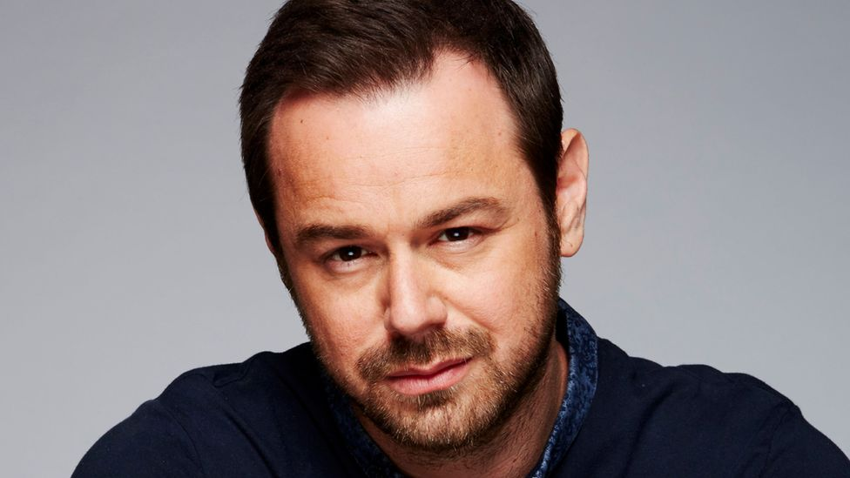
Danny Dyer has a well-known Cockney accent
By Shivani Chaudhari and Sonia Watson. BBC News, Essex
The King's English and Cockney are no longer common dialects among young people in the South East of England, according to a new study.
https://www.bbc.com/news/uk-england-essex-67289519

Researchers from the University of Essex studied the dialects of a group of 18 to 33-year-olds in the region.
They identified three voices, estuary English, southern British English and multicultural London English.
Project leader Dr Amanda Cole said the latter was "a really innovative and interesting accent".
"Multicultural London English is a relatively more recent accent, it is thought to have be around since the 80s, it has a lot in common with the cockney and South Eastern dialects," she said.
"But it also has linguistic features that have come from other languages and other dialects of English."
Young people with a multicultural London English accent made up 25% of the 193 people who took part in the study, she said.
Image caption,
Dr Cole said a quarter of people who took part in the study spoke with a multicultural London English dialect
People with this accent tend to say vowels in their words like "bate" and "boat" with the tongue starting at a point higher up in the mouth compared to people with the standard southern British English, Dr Cole added.
This means they will sound like "beht" and "boht".
People with this accent tended to be Asian British or Black British from London and across the South-East England, she said.
- Do you need to be from London to be a cockney?
In recent years, Cockney and the King's English were spoken by people of all ages, but now 49% of the participants spoke in a standard southern British English accent, which the study said was a modern, updated version of received pronunciation.
People with this accent tended to say words like "goose" with the tongue further forward in the mouth (sounding a bit more like "geese") than received pronunciation.
Researchers said this change even happened in the accent of the late Queen Elizabeth II over her lifetime.
Around 26% of the participants spoke estuary English, which had similarities with Cockney but was closer to received pronunciation.
Participants with this accent pronounced words like "house" like "hahs" but the study said it was not as extreme as Cockney.
Estuary English is spoken across the South-East, particularly in parts of Essex, and is similar to how TV personality Stacey Dooley, singers Olly Murs and Adele or The Repair Shop's Jay Blades talk.
The study said: "This occurs as a result of the increased movement of people resulting in greater contact between dialects, the growth of universal education and literacy, and people buying into the idea that there is a 'correct' or 'standard' way of speaking."
Find BBC News: East of England on Facebook, Instagram and X. If you have a story suggestion email eastofenglandnews@bbc.co.uk

